Week in Review, Issue 10 - January 4-10
Alex Shvartsman

GRAND PRIX: NEW ORLEANS
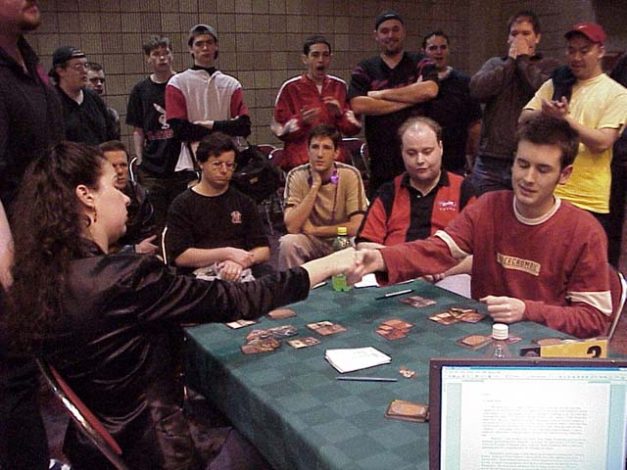
Although 2001 just began, this tournament is likely going to remain one of the most memorable events of the year. Its location and format drew a large crowd of close to 450 people. In addition to being a well-organized and satisfactory tournament, New Orleans was home to a number of interesting stories that will be talked about in the tournament circuit long after the event.
PTLA winner Trevor Blackwell was the only player to go undefeated at GPNO. He finished twenty-first. How, you ask? Blackwell went out to Bourbon Street Saturday evening - and stayed there until morning. He returned to the tournament venue at 9 am - except that the first draft was scheduled for 8:15! Apparently, he had asked some players when the tournament was starting and they told him 9 am. Unfortunately, they were playing in the Saturday PTQ! Blackwell was forced to "sit out" three rounds, ending up with three losses - while his opponents, including Top 8 finisher Steve OMS, were fortunate enough to get byes at the top table. Blackwell won his second draft table 3-0, getting 1 PT point and $250 for his trouble.
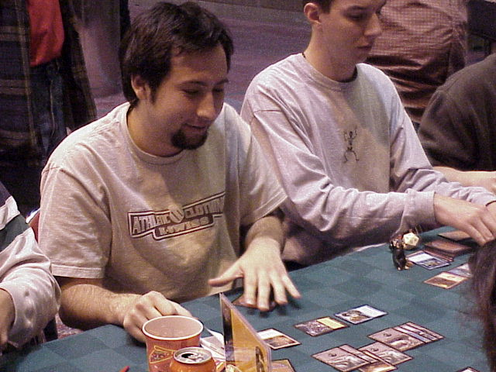
Dave Humpherys lost not one but two games in a row to an opponent who would generate enough mana to cast Obliterate and then summon a creature (Kavu Aggressor, if memory serves me right) on the same turn.
Andrew Diaz-Matos, a lawyer from NYC, who never as much as made Day 2 of a Grand Prix before, dominated Day 1 and did well enough on Day 2 to come within striking distance of the Top 8 - he only missed out by losing the crucial last round match to veteran Jamie Parke.
Mike Pustilnik continues his streak of GP dominance this season, with yet another Top 16 finish.
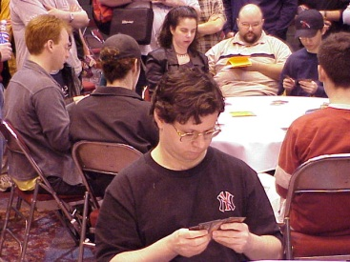
Gary Rush, who played in several Pro Tours before but hasn't had a title finish yet, had not lost a match until the semi-finals.
Dustin Stern, who had never played on the Pro Tour, made his second Grand Prix Top 8 in a row (first being GP Dallas). He will begin his PT career in LA and is already qualified for Tokyo and Barcelona, and is definitely a player to watch.
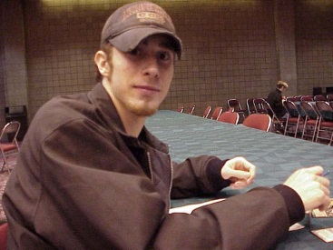
Steve O'Mahoney Schwartz played popular Internet columnist Sol Malka for a Top 8 spot. He won a very close match by attacking with Crosis, the Purger enchanted with an Armadillo Cloak! Take that, Brian Kibler!
Michelle Bush, widely regarded as the top female player, has become the second woman to make Top 8 of a Grand Prix, and the first one to do so in an individual event. Bush took out a number of tough opponents, including teammate Rob Dougherty to make it all the way to the finals.
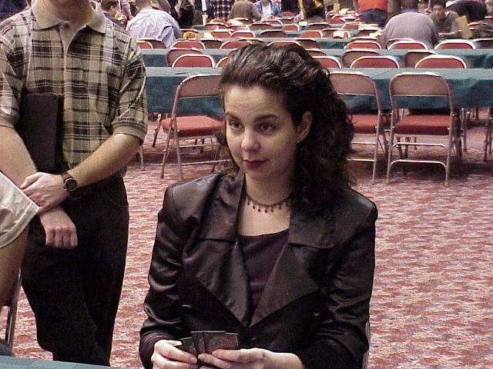
Brothers Bill and Robert Stead met in the second-to-last round of swiss, both in contention for the Top 8. Younger brother, Bill Stead, chose to concede the match to Robert. This way both brothers could make the Top 8 if they won the last round of swiss. Robert lost his match to Dustin Stern, but Bill defeated Deadguy Tony Tsai to make the Top 8. Karma was on his side, as he defeated Eric Kesselman, Steve OMS and Michelle Bush to win $2400, 6 PT points and the title of champion.

GRUDGE MATCH FINALS

Finals of the Grudge Match between New York and Boston were held on Friday night at the venue of GP New Orleans. New York's Zvi Mowshowitz defeated Boston's Joe "Mouth" Kambourakis 2-0 matches. Zvi had favorable pairings, when his Fires deck went up against Mouth's Blue Skies, then Zvi's U/W control deck defeated Mouth's copy of Brian Kibler's "Red Zone." The last matchup would have been Zvi's W/b rebels, against Mouth's W/u rebels.
Detailed coverage of the Grudge Match finals is posted on NeutralGround.net.

COMING UP: GP AMSTERDAM
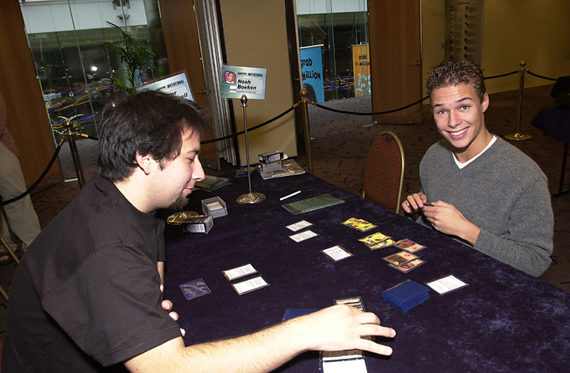
Holland's finest
Although only 360 players have pre-registered so far, it is fully expected that this Grand Prix might beat last year's attendance of 599 player. Many of the top North American players will travel to this tournament and its location in the center of Europe (and various non-Magic related side activities there) are guaranteed to lure competitors from all over the continent. Rumor has it that Jon Finkel himself will be attending.
Amsterdam was the location of the first ever Grand Prix in 1996 and is the first city to host three of these tournaments.

YOUR MANA'S WORTH
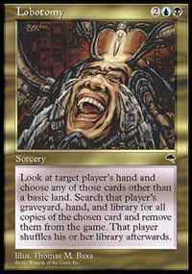
Last week's column generated a lot of feedback. First of all, evidently when Lobotomy is Misdirected back to its caster, he does not have to remove any card from the game at all. He must "choose a card in his hand" but then he may choose not to find any copies of that card when he "searches" his hand, graveyard and library for copies of that card. To respond to an e-mail that questioned the morals of "not finding" a card - this is a perfectly legal and acceptable play.
A number of other players wrote in regarding the Play of the Week. They felt that if a Sliver Queen is discarded with a pair of Volrtath's Shapeshifters in play, only the one with a later time-stamp will be buried. I am happy to report that I did not screw that one up. As confirmed by a number of high-level judges, both Shapeshifters will be buried, as they became Legends at the same time.
Well, glad that's taken care of. Perhaps I should stick to writing about somewhat simpler cards. So here are some neat tricks you can pull off with a Goblin Hero...

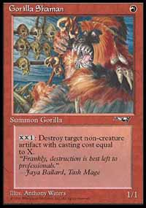
MAGIC TRIVIA
I was thinking about cool features to add to this column, and decided that some neat Magic trivia would be perfect. Every week I will try to stump you guys will a neat trivia question, and reveal the answer in the next column. There is no prize and please do not e-mail me with your answers, just wait until the next column to see if you are right.
We are going to start off with an easy one (courtesy of Mike Pustilnik). Name a non-creature artifact that cannot be destroyed by Gorilla Shaman, no matter how much mana you have available.

BEST OF THE NET
The best read this week is Mike Flores' article on The Dojo where he examines the philosophy behind, and implications of, The Rogue Strategy.

PLAY OF THE WEEK
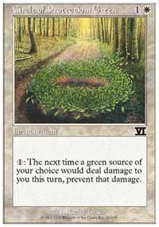
This play took place at Pro Tour: Chicago. Two-time Canadian national champion Gary Krakower was playing against one of the competitors from Japan. For those who do not know Krakower, he is one of those Rogue players Flores talks about in his article. He often plays insane decks that just work.
Krakower's Chicago deck was quite insane. He's got Kavu Chameleons, Tariffs and other strange goodies maindeck. His opponent this round is a rogue player too though. Krakower quickly loses a game to his own army after Bribery resolves three times!
Krakower makes some sideboarding decisions, and they are off to the next game.
Things are looking grim yet again, as Krakower is facing his own Blastoderm and Kavu Chameleon on the side of his opponent's mono blue deck. Fortunately, Disrupting Scepter ensures that his opponent has no countermagic (told you this guy was rogue!), but what can a green-white deck draw to make things better here?
Krakower draws and casts Circle of Protection: Green!
"I thought about it and realized that my creatures are a lot more scary than his," Krakower explained later. "So I boarded in a COP: Green against his Bribery strategy."
Krakower's opponent fails to draw his one Air Elemental, Blastoderm eventually fades away, and Krakower earns a well-deserved victory.

BAD PLAY OF THE WEEK
As reported by one of the readers, his friend who is new to the game made the following play:
Turn 1: Island, go.
Turn 2: Thran Quarry, Energy Field, go.
Ah, to be a new player again.
Got a play of the week or some other interesting story for this column? Please e-mail me at ashv@concentric.net.

